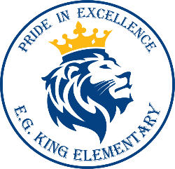
Community Council Agenda
January 09, 2020
FUTURE MEETING DATES:
February 6
March 5
April 9
**All meetings start at 6pm in the library**

- Welcome

- Amy Tyrell

- 2019-2020 Budget

- SEL

- School Improvement Plan (SIP)

- Layton City Scholarship

